**SOFTWARE ENGINEERING GROUP PROJECT**

**ERROR404 - CLUB EVENTS**

Team Members : Amoga, Manu and Kushal

**Sprint Schedule:**

1. Sprint 1 (2 weeks):

* Week 1: Implement the core features of the app (e.g., ability to add events, display events)
  + Feature 1 - addition of user information in the database
  + Feature 2 - Removing/Deleting the event
  + Feature 3 - adding club event on the website
  + Feature 4 - User profile feature

These are some of the key features that need to be functional even for a prototype.

* Week 2: Test the app and fix any bugs
  + We would use the application ourselves as users first to fix the obvious bugs if any.
  + We would then choose a certain number of potential or voluntary users to test the application and report any bugs or improvements.

1. Sprint 2 (2 weeks):

* Week 3: Implement additional features (e.g., user authentication, notifications) if required/ in demand/possible.
  + Feature 1 - Club rankings
  + Feature 2 - Editing the post of the club event
  + Feature 3 - Wrong id or password message notification
  + Feature 4- Feedback and ratings provided by the user.
  + Feature 5- Notify the user a few minutes before the event.
* Week 4: Test the app and fix any bugs
  + We would select the same users who used the application in the first testing stage.
  + We would then go ahead and find some new testers to find the first look review of the application after the additional features have been added.

1. Sprint 3 (1 weeks):

* Week 5: Improve the user interface and user experience and final testing and bug fixing and deployment
  + Based on the reviews provided by the test users we would implement the changes accordingly and finish up the product to prepare for deployment.
* Daily stand-up meetings (15 minutes) to discuss progress and any issues in the context of that sprint.
* Sprint planning meetings (1-2 hours) at the start of each sprint to plan the work for that sprint
* Sprint review meetings (1-2 hours) at the end of each sprint to review the work done and gather feedback
* Sprint retrospective meetings (1 hour) at the end of each sprint to reflect on the process and identify areas for improvement.

All of these meetings will be included in the duration of the actual sprint mentioned above.

We will be using Trello to manage the updates and ideas on a virtual board. We will be using the checklists and due date function to make sure we know what to do and by when and if it is done or not.

**Class Functions:**

**Based on pages**

User:

* userinputUsername [String]
* userinoutEmail [String]
* userinputPassword [String]
* userinputTitle [String]
* userinputDescription [String]
* userinputDate [Integer]
* userinputTime [Integer]
* Userinputprofilepic [Jpeg]
* UserinputRatings [Integer]
* Userinputfeedback [String]

RegisterPage:

* setUsername [String]
* setEmail [String]
* setPassword [String]
* ConfirmPassword [String]
* Register will go to login page if true [Bool]

LoginPage:

* getEmail [String]
* getPassword [String]
* Login will go to home page if true [Bool]
* Forgotpassword

PageContoller():

* Event [Bool] will go to events page if true
* About [Bool] will go to About page if true
* New post [Bool] will go to New post page if true
* Event [Bool] will go to events page if true
* Account [Bool] will go to Account page if true
* Logout [Bool] will go to login page if true
* Searchbar [String]

HomePage:

* PageContoller()

EventPage:

* Feedback [String]
* Notifyme [Bool] will notify the user if true
* Event_title [String]
* EventDescription [String]
* Delete_post [Bool]
* PageContoller()

AboutPage:

* PageContoller()
* Feedback_user [String]
* Report [String]

AccountPage:

* PageContoller()
* getProfilepic [Jpeg]
* Update_info [Bool]

NewPostPage:

* setTitle [String]
* PageContoller()
* setDescription [String]
* setDate [String]
* setTime [String]
* Post will go to home page if true [Bool]

FeedbackPage:

* PageContoller()
* setRating [Integer]
* setfeedback [String]

**Main variables in the database that will stored / modified / Updated:**

* Username
* Email
* Password
* Title
* Description
* Date
* Time
* Feedback
* Rating
* Profilepic
* Notifyme

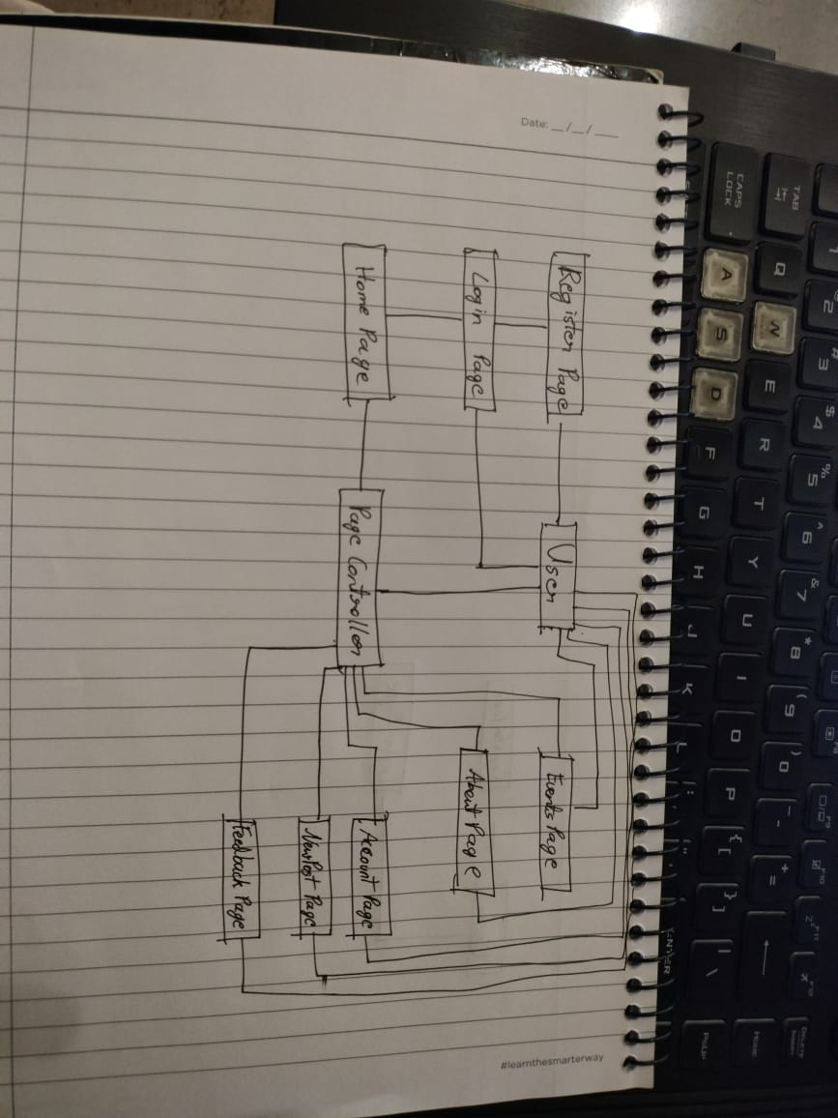

Diagram of the connection between pages and user based on the above given class members and functions.

Some of the transitions in the application.